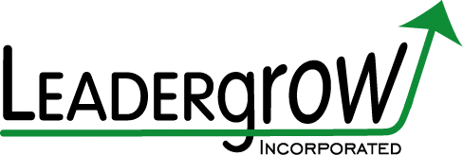

Trust and Solving Problems
by Bob Whipple, MBA, CPLP

When low trust teams have to tackle real problems, it can be a disaster. The interpersonal issues keep getting in the way. If you can build high trust into the team dynamic, then the efficiency of solving problems goes up dramatically. It is important to assess the level of trust on every team. I have developed a quick survey that can be very helpful at understanding the level of trust on your team. If you would like access, just drop me a line. There are numerous other surveys available online if you just do a quick search.
I sit on several Boards of Directors, and one of them is a pretty low trust group. When a problem comes up, it seems the team is always tiptoeing around the interpersonal issues. We can discuss things for an hour and not get close to the real problem at hand. We quite often end up putting “BandAids”® on the symptoms hoping the problem will resolve itself. We all know the world does not work that way.
Another BOD I sit on is a particularly high trust group. They solve problems quickly and efficiently because they get to the heart of the issue fast without playing games with each other. One hallmark of high trust groups is that they solve problems quickly and with high quality solutions while having fun. Low trust groups often fail to solve the real problem and frequently have to deal with a lot of acrimony.
Exercise for you: Take the time today to do an assessment of the trust level on your team. This is especially important if your team seems to struggle at times. Make sure all members of the team take the instrument and share the data. If trust is lacking, then get a commitment to do something about it.
Putting up with interpersonal issues that result from low trust is a sign of mediocrity. You can move to excellence simply by investing some time and energy into raising the trust level. It is not impossible, and your team will become much more efficient.

The preceding was derived from an episode in “Building Trust,” a 30 part video series by Bob Whipple “The Trust Ambassador.” To view three short (3 minutes each) examples at no cost go to http://www.avanoo.com/first3/517

Bob Whipple, MBA, CPLP, is a consultant, trainer, speaker, and author in the areas of leadership and trust. He is the author of: Trust in Transition: Navigating Organizational Change, The Trust Factor: Advanced Leadership for Professionals, Understanding E-Body Language: Building Trust Online, and Leading with Trust is Like Sailing Downwind. Bob has many years as a senior executive with a Fortune 500 Company and with non-profit organizations. For more information, or to bring Bob in to speak at your next event, contact him at www.Leadergrow.com, bwhipple@leadergrow.com or 585.392.7763

New Book in 2014 - Trust in Transition: Navigating Organizational Change For more information go to www.astd.org/transition .

